REST Assured API Automation Test Report
Prepared by: Justin Philip
Date: 25 June 2026
GitHub Repository:
- API Automation Project: 🟡 EDIT THIS (Paste your repo link)

1. Objective
The objective of this automation is to validate API functionality using Rest Assured.
The automation focuses on:
- Verifying API responses
- Validating status codes and response bodies
- Ensuring endpoints behave correctly under different scenarios

2. User Story
As a system user, I want APIs to return correct responses so that the application functions reliably and data consistency is maintained. I want to retrieve all booking ids, check details for particular ids, do basic authentication and verify orderDetails.

3. Application / API Under Test
- API Type: RESTful APIs
- Base URL: https://restful-booker.herokuapp.com
- Environment: Local
Modules Covered:
- Authentication APIs
- All BookingIDs APIs: https://restful-booker.herokuapp.com/booking
- BookingID Specific: https://restful-booker.herokuapp.com/booking/:id
- Verifying Booking Details

4. Environment & Setup
Technology Stack:
- Language: Java
- Framework: Rest Assured
- Assertion Library: JUnit 5
- Build Tool: Maven
- Test Runner: Maven Surefire Plugin
- Environmental Variables: stored in .env file

Setup Instructions
easeMyTrip_URL=https://www.easemytrip.com
restful_broker=https://restful-booker.herokuapp.com
username=admin
password=password123

5. Framework Design
5.1 Architecture Overview
The framework is designed using a structured approach separating test logic and API interaction layers.

5.2 Project Structure
- src/test/java/tests → Test classes
- specFactory/ → API request handling
- TestEnvCheck/ → Helper classes
- resources/ → Test data and config
- pom.xml → Dependency management

5.3 Design Approach
- Rest Assured is used for API requests and validations
- JUnit 5 is used for assertions and test lifecycle
- Test cases are designed to validate API responses independently
- Request and response handling is modularized

5.4 Test Lifecycle
- Test execution handled through Maven Surefire
- Each test runs independently
- Setup handled via configuration files or base test classes

6. Test Approach / Strategy
- API testing is conducted using functional validation
- Focus on:
  - Status code validation
  - Response body verification
  - Schema validation (if implemented)
Test Categories:
- Smoke → Basic API availability
- Regression → Full API validation

7. Scenarios Covered
- GET method for different api endpoints
- GET method for particular ID
- POST method for Auth
- Extracting booking id from new from new Booking and verifying details

8. Test Scenarios / Test Cases

Scenario 1
- Scenario Name: GET method for different api endpoints
Steps:
- Send API request
- Validate response
Expected Result:
- API should return status code 200
Actual Result:
- API returned status code 200
Status: Pass
Code: 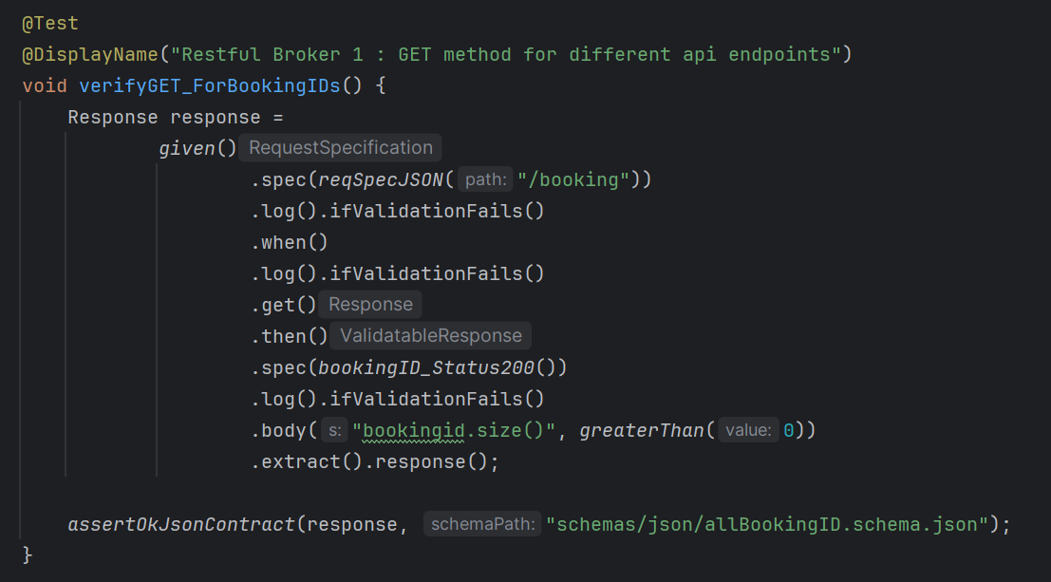

Scenario 2
- Scenario Name: GET method for particular ID
Category: Regression
Steps:
- Send request with parameters
- Validate response body
Expected Result:
- Response should contain expected data
Actual Result:
- Response contains expected data
Status: Pass
Code: 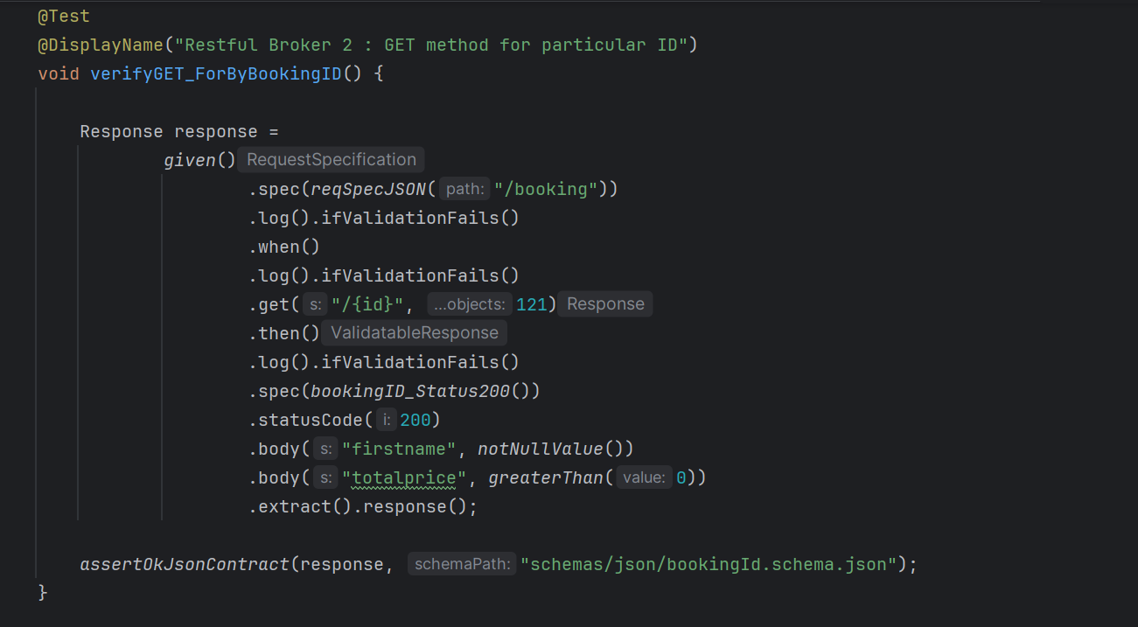

Scenario 3
- Scenario Name: POST method for Auth
Category: Regression
Steps:
- Send request with parameters
- Validate response body
Expected Result:
- Response should contain expected data
Actual Result:
- Response contains expected data
Status: Pass
Code: 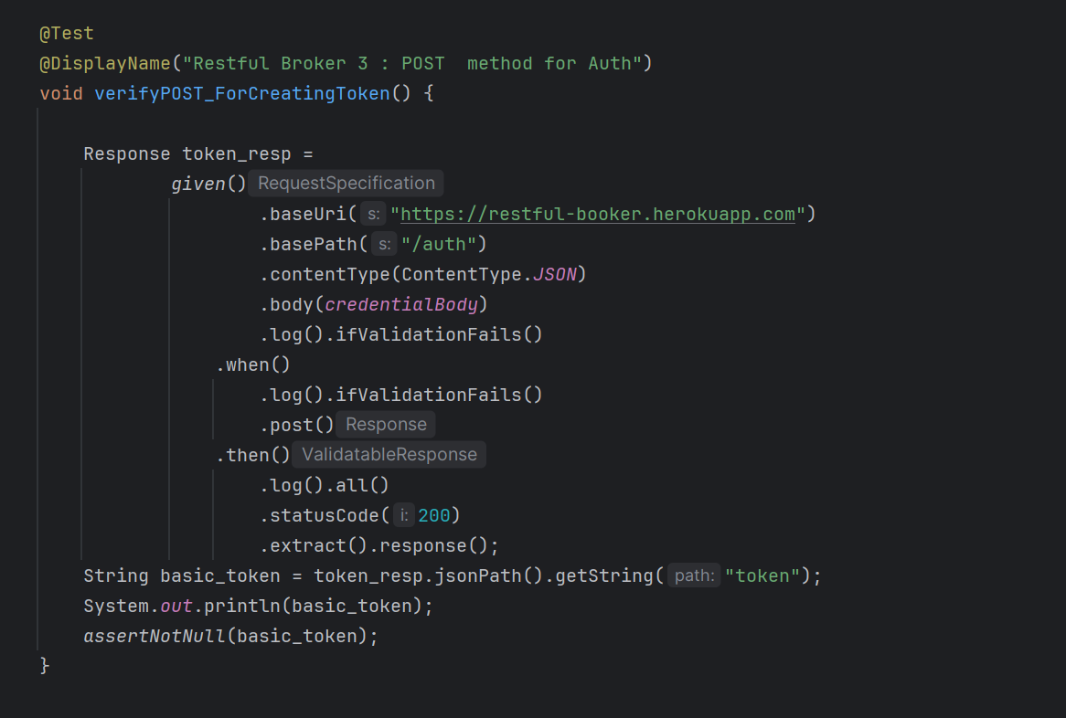

Scenario 4
- Scenario Name: Extracting booking id from new from new Booking and verifying details
Category: Regression
Steps:
- Send request with parameters
- Validate response body
Expected Result:
- Response should contain expected data
Actual Result:
- Response contains expected data
Status: Pass
Code: 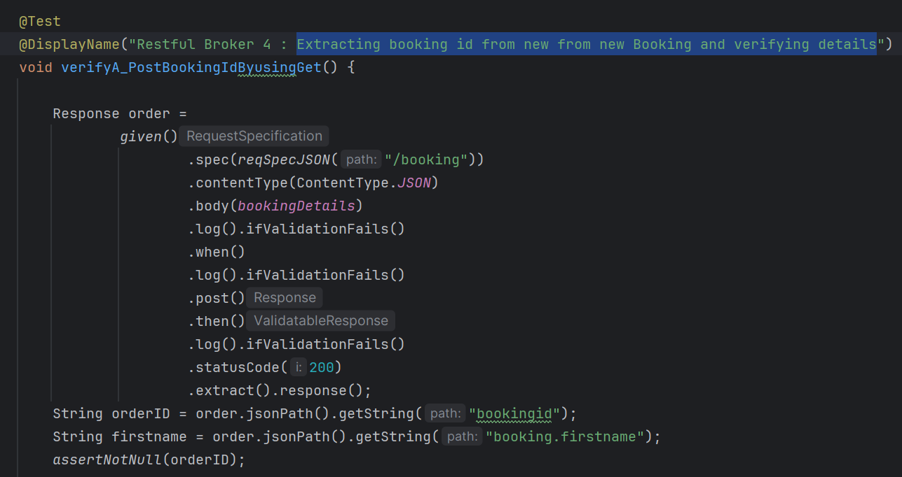
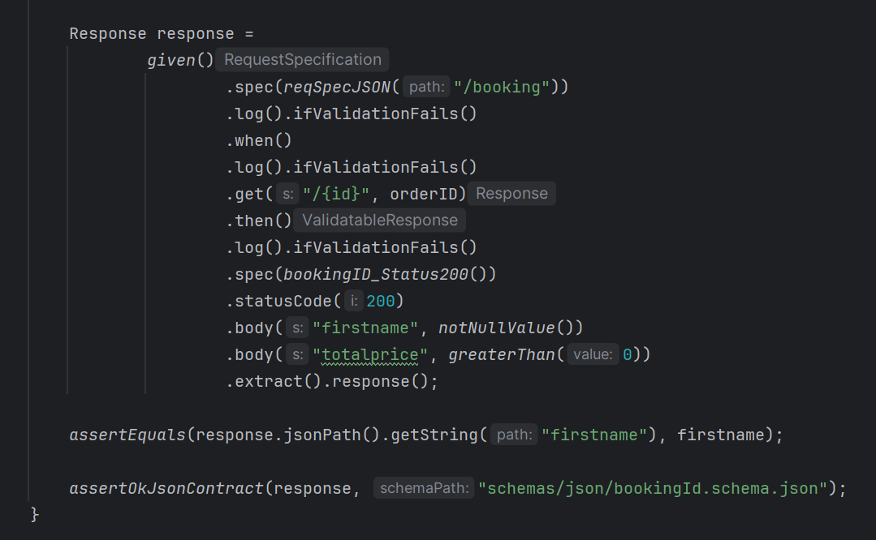

9. Validations & Assertions
- Status code validation using:
Java
assertEquals(200, response.getStatusCode());

Show more lines
- Response body validation
- Header validation
- JSON path verification

10. Execution Details
Execution Features:
- Tests executed using Maven Surefire
- Supports parallel execution (if configured)
- Integrated with CI pipelines

11. Reporting & Evidence
- Console logs for API responses
- Maven Surefire test reports generated
- Execution logs available for debugging

12. Execution Summary
Scenario | Category | Result
Test 1 | Smoke | Pass
Test 2 | Smoke | Pass
Test 3 | Smoke | Pass
Test 4 | Regression | Pass
Overall Result:
- Total Tests: 4
- Passed: 4
- Failed: 0
Screenshot:
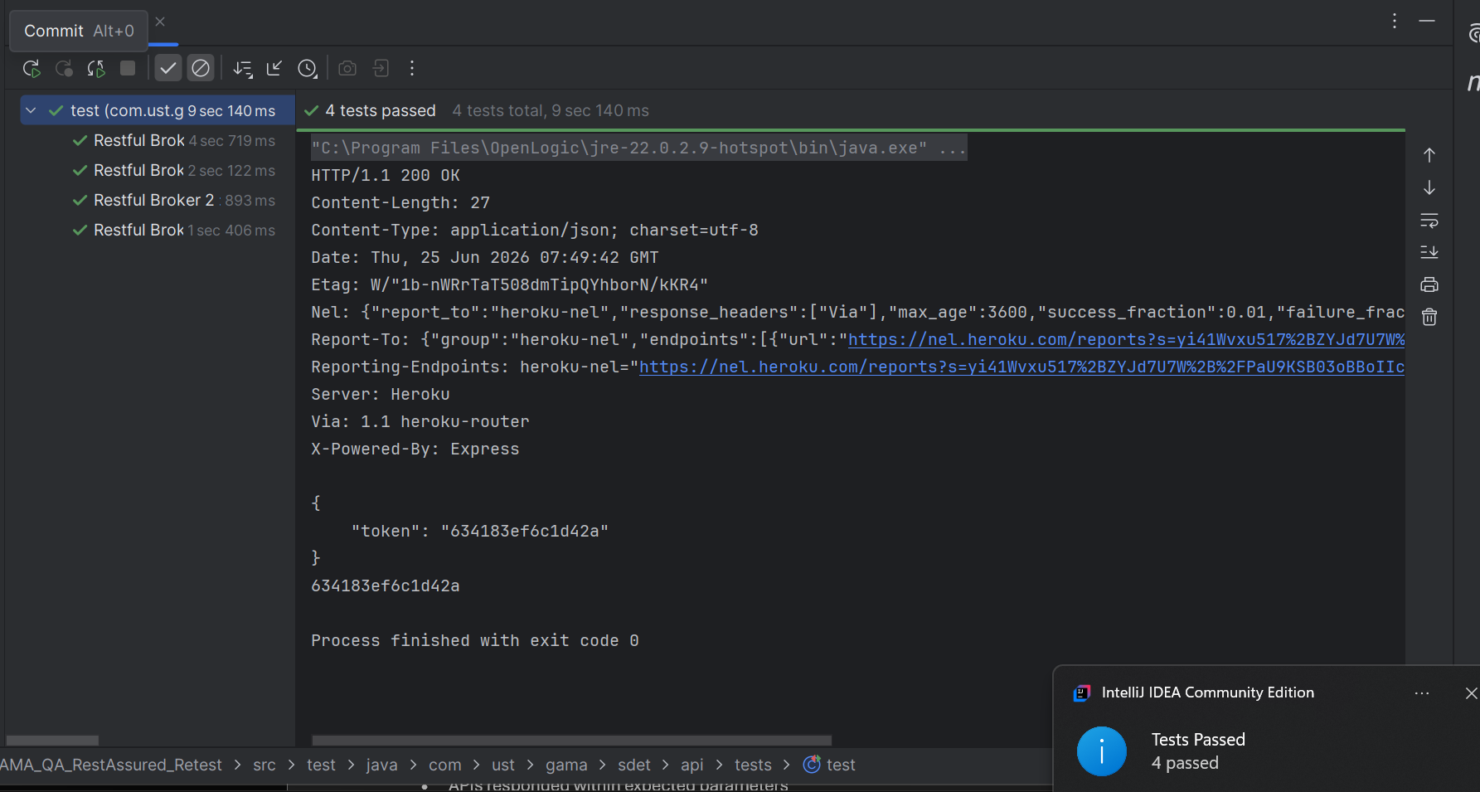
13. Observations / Findings
- APIs responded within expected parameters
- Data consistency maintained across endpoints
- No critical defects observed

14. Issues & Limitations
- Limited test coverage for edge cases
- No performance or load testing included
- Error scenarios need expansion

15. Best Practices Followed
- Clean separation of request and validation logic
- JUnit5 assertions used effectively
- Maven used for build and execution
- Modular and maintainable structure
- Clear and readable test cases

16. Conclusion
The REST Assured automation framework successfully validates core API functionalities.
The APIs are stable for the tested scenarios, and the framework provides a solid foundation for expanding test coverage and integrating advanced features like reporting and CI/CD pipelines.
The tests all passed.

GET
Header: application/json
Body: NA
Basepage: https://flightservice-web.easemytrip.com/EmtAppService/AppInitialize/GetCoupons
Hotels: https://www.easemytrip.com/flight-list-banner/hotel-campaign.json?v23
https://www.easemytrip.com/offers/offerjson/cab-offers.json - GET
https://widget.trustpilot.com/trustbox-data/5419b6ffb0d04a076446a9af?businessUnitId=5b0d3b6f03ad270001a45b1c&locale=en-US
https://widget.trustpilot.com/trustbox-data/54ad5defc6454f065c28af8b?businessUnitId=5b0d3b6f03ad270001a45b1c&locale=en-US&reviewLanguages=en&reviewStars=5&reviewsPerPage=15

POST - https://mybookings.easemytrip.com/Mybooking/UpdatePersonalData/
https://www.easemytrip.com/search.aspx/CheckSignIn

